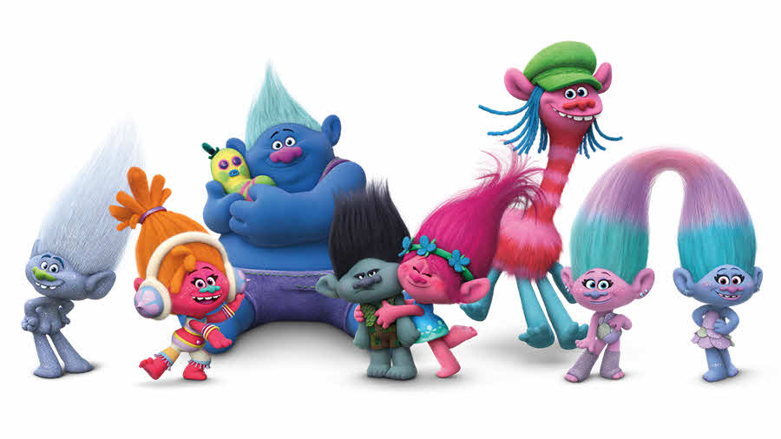
Trolls Movie Workout
Bergens eat or talk about eating a Troll- 10 Squats
Singing- Jog in place
Someone says “Poppy”- 10 Mountain Climbers
Someone says “Happy”-10 Crunches
Someone says the phrase “No Trolls Left Behind”-10 Lunges
Hourly hug time- 5 Push Ups
Branch says something negative-5 Burpees
See a rainbow- 10 Jumping Jacks
Glitter shoots out of anything- 10 Jumping Jacks
A Bergen takes a Troll- 3 Jump Squats

